**PART 2**

The Netlogo model here tries to mimic an Economic concept known as the “Tragedy of commons”. It basically tells that shared resources tend to be over exploited even subjected to rational usage. Here, in this system we work on 3 fields. Field 1(green grass) which belongs to Farmer A, Field 3(blue grass) which belongs to farmer B and field 2(yellow grass) which can be shared among the two farmers. Farmer A owns white sheeps which can graze on field 1 & 2 while farmer B owns orange sheeps which can graze on field 2 & 3.

Farmers are allowed to choose an optimum or Maximum number of sheep which they want to attain, which is set by a slide on the main interface under each farmer’s settings. If the optimum number for any farmer is reached the sheeps will stop reproducing. A message is displayed when a farmer’s last sheep starves to death.

The turtles here are in the form of sheeps: white(Farmer A) and orange(Farmer B), colors help in avoiding confusion and also make the model look interesting. The sheeps gain energy by eating grass and drain energy when they move from one patch to another. Initially sheeps are initialized with a random energy. Reproduction and death of a sheep both depend on their respective energy, if a sheep’s energy surpasses the reproduction threshold value, the sheep or turtle breaks into two of its kind. If the energy of the sheep falls to 0 the sheep dies.

When a sheep is standing on a colored field the sheep would eat the grass and turn the patch color into a lighter shade of that field color. There is a grass regrowth rate which can be altered by a slide on the main interface. Essentially a countdown starts once a patch is eaten by a sheep and once the countdown reaches 0 the grass regrows on the patch.

***Q.****In this implementation, use slider variables to set the maximum number of sheep that each farmer wants to have. Farmers don’t want their sheep to starve but they also want maximum sheep.*

*By manually adjusting the sliders try to find the maximum number of sheep that farmers can have before the population of sheep starts to oscillate up and down (indicating a boom and bust of starvation and breeding).*

Initial no of sheeps are kept at 14.

Energy gain from food is kept at 4

Threshold energy for reproduction is kept at 12

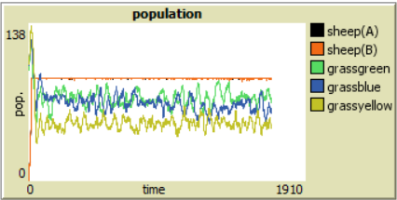

*Maximum no. of sheep is 90*

In my model, the maximum number of sheep each farmer can have came out to be 90 before the population started to oscillate. The above graph shows a constant population for sheeps A and B shown by the black and orange lines respectively.

When I tried to increase the maximum number of sheeps to 100 and forth the population started to oscillate as show below:

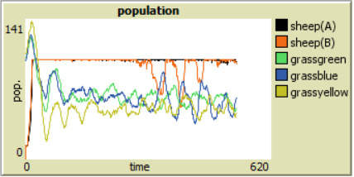

*Maximum no. of sheep is 100*

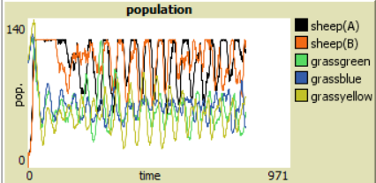

*Maximum no. of sheep is 120*

*Report on what happens to the grass in each section 1, 2 and 3.*

The grass on field of farmer A and B show the same sort of consumption with small variation with almost regulation oscillation after fixed number of sheeps are grazing on it.

The grass on the shared field (yellow grass) takes a bigger hit as it’s continually being eaten by both the farmer’s sheep and is visibly less then both the other field’s grass as seen in the graph below.

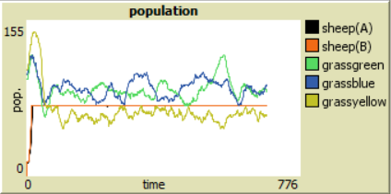

*Maximum no. of sheep is 70*

***Q.****Also report on what happens if you stop farmers from using section 3. How many sheep can they run now?*

When the farmers are stopped from using the shared field the maximum number of sheeps for each farmer takes a dive. I found out that a stable population was achievable when the maximum number of sheeps was set at 50. While setting the maximum to 60 triggered oscillations but of less magnitude, but setting the number to 70 made oscillations larger which are clearly visible in the graphs given below.

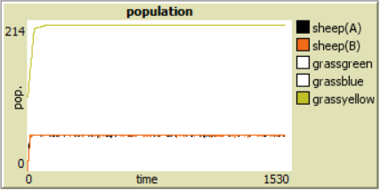

*Maximum no. of sheep is 50*

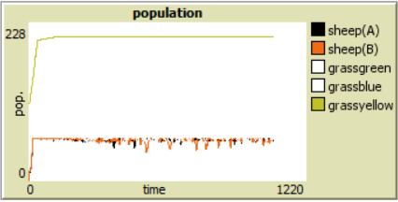

*Maximum no. of sheep is 60*

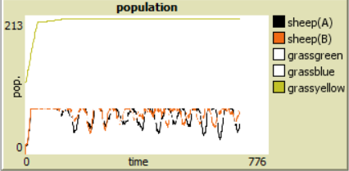

*Maximum no. of sheep is 70*

***Q.****What happens if you let one farmer use section 3 but not the other? Address these questions in the section of the report dedicated to this part of the exercise.*

If we let one farmer(A in this case) use the shared field and not the other one we see a change in the maximum no. of sheep (120) the farmer can now have before the population starts oscillating.

There was also a change in the consumption of the shared grass. Earlier when the field had about 120 sheeps in total (A + B) the shared grass(yellow) was being eaten at a greater pace then the others. Now with 120 sheeps grazing on field 1 and 2 the grass consumption for the shared grass has even out almost like to the other two grass fields.

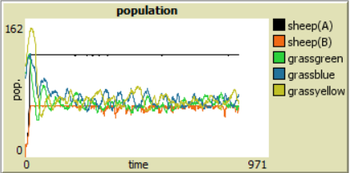

Maximum no. of sheep for farmer A is 120 and farmer B is 60.